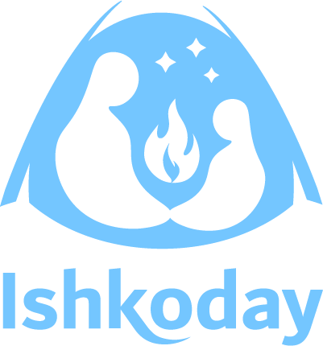
Ishkoday Assembly 2025
Agenda – Chelsea Toronto
October 20th and 21st, 2025

Sunday, October 19th, 2025
6-8 pm | Pre-Registration

Monday, October 20th, 2025
8-9 am | Registration & Coffee  Churchill Court
9-9:45 am | MC: Adam McLaren  Opening Prayer and Greeting  Opening Prayer – Elder and Customary Greetings  Drum: Biine Elijah  Opening Comments  ONWAA President – Samantha Maracle  ONWAA Executive Director – Jessica Nadjiwon
9:45 – 10:00 | Boodawewin App Presentation  F: Nick Puran
10:00 – 10:15 | Consumer Energy Efficiency Training  F: Sheldon Adams
10:15 – 10:30 | Energy Research in First Nations Communities  F: Adam McLaren
10:30-10:45 | Break
10:45 | Youth Speaker: Serena Mendizabal
11:05 | Keynote Speaker: Micheal Redhead Champagne
12:00 | Lunch
1-2:30 PM | NWMO – Nuclear Waste Workshop and Focus Group  BB33 | Energy Programs Outlook  F: Sheldon Adams and OESP Intake Team  Mountbatten A | Healthy Homes Training  F: Home Inspectors Group  Mountbatten B | Efficiency First: Aligning Income Assistance and Energy Upgrades to End Energy Poverty  F: Abhi Kantameni  Churchill Ballroom
2:45 pm – 4:15 pm | NWMO – Nuclear Waste Workshop and Focus Group  BB33 | Energy Programs Outlook  F: Sheldon Adams and OESP Intake Team  Mountbatten A | Manito Aki Inaakonigewin F: Treaty 3 TPU Department  Mountbatten B | Community-Led Project Implementation: Wisdom & Experiences from Sacred Earth  F: Serena Mendizabal  Churchill

Tuesday, October 21st, 2025
8-9 am | Coffee
 | How do we make energy efficiency “Sexy”?  F: Adam McLaren and Ray Fox  BB33 | Showcase: Home Energy Efficiency Training  F: Sheldon Adams  Mountbatten A
 | Navigating “NDN” Country  F: Jessica Nadjiwon  Churchill Ballroom | Energy as a Relationship F: Nicholas Puran Mountbatten B
12:00 -12:30 | Final Goodbyes in the Ballroom

Pre-Registration October 19th from 6-8pm.
We are encouraging attendees to pre-register for the event at this time. We are attempting to avoid long lines and delays.
Opening/Closing Protocols, Plenary and Guest Speakers
MC: Adam McLaren
Opening Prayer: David Fiddler
Drum: Biine Elijah
FNESA/Ishkoday Chair: Samantha Maracle
Executive Director: Jessica Nadjiwon
Boodawewin Application: Nicholas Puran
Energy Research in First Nations Communities: Adam Mclaren
Youth Speaker: Serena Mendizabal, Sacred Earth Solar
Keynote Speaker: Michael Redhead Champagne
October 20th – Afternoon Workshop Descriptions 1.5 Hours
NWMO Siting Process Focus Group
Facilitator: Amy Ingram, NWMO
Description: In June 2025, the Nuclear Waste Management Organization (NWMO) launched a two-year engagement process with Indigenous Peoples and Canadians to gather feedback on developing a site selection process for the next deep geological repository (DGR).
Following the Minister of Natural Resources’ endorsement of the recommendations included in Canada’s Integrated Strategy for Radioactive Waste, NWMO is now responsible for the safe, long-term management of intermediate-level and non-fuel high-level radioactive waste. This waste results from generating electricity and producing medical isotopes.
This new process is separate from NWMO’s ongoing work over the past 30 years to manage used nuclear fuel. Wabigoon Lake Ojibway Nation and the Township of Ignace have been selected as host communities for the first DGR to store this waste.
NWMO invites you to a workshop to learn more about the proposed siting process, provide input, and share your thoughts. Everyone is welcome to participate in the important conversations about the health, safety and security of people and the environment for generations to come.
Max of 25 participants.
Healthy Homes Training
Facilitator: Home Inspectors Group
Description: Come learn about the science of building as it pertains to energy efficient homes.
Manito Aki Inaakonigewin: the "Great Earth Law" in Treaty #3
Facilitators: Hailey Krolyk, Gary Allen, and Kevan Sumner
Description: At the beginning of time, Gichi-Manito bestowed upon the Anishinaabeg duties, responsibilities, and spiritual ways to protect, care for, and respect the land. In 1993, when Grand Council Treaty #3 was approached by Bell Canada with a proposal to install fibre optic lines through Treaty #3 Territory, it was decided that the sacred laws should be translated for communication with project proponents and colonial governments. Over four years, a traditional process ensured the laws were documented appropriately and adopted in ceremony, and since that time the written version of the law has guided Grand Council's approach to proposed projects in Treaty #3 Territory.
Efficiency First: Aligning Income Assistance and Energy Upgrades to End Energy Poverty
Facilitator: Abhilash (Abhi) Kantamneni
Description: Most Indigenous and low-income households will only get one chance to benefit from an energy efficiency or housing upgrade. Why not make that moment count? By aligning income assistance with energy efficient upgrades, we can ensure homes are not just affordable, but also livable, comfortable, and resilient to extreme weather - particularly for vulnerable households that need it the most.

Community-Led Project Implementation: Wisdom & Experiences from Sacred Earth
Facilitator: Serena Mendizabal
Workshop Details: Sacred Earth Solar (SES) will present the key steps they’ve taken in their renewable energy projects, covering everything from initial project proposals to financing, construction, and long-term maintenance. This will be followed by a workshop where participants will use SES resources to refine their ideas, identify key partners, and begin planning community engagement strategies. Participants will discuss their project challenges, opportunities, and potential solutions with peers and experts.
Energy Programs Outlook
Facilitator: Sheldon Adams and OESP Intake Team, FNESA
Description: We will provide an overview of current Energy Programs as well as their intended purpose. Along with the details of each program, we will provide guidance on applying for each of the programs and discuss the different criteria of each program.
Day Two - October 21st Workshops 3 Hours
How to make energy efficiency “sexy”?
Facilitator: Adam McLaren and Ray Fox
Description: A multimedia arts-based workshop designed to create a space to brainstorm on how to make Energy Efficiency - appealing, accessible, trendy, fun, and sexy!
The benefits of energy efficiency are for everyone!
Showcase: Residential Energy Efficiency Training
Facilitator: Sheldon Adams
Description: Ishkoday has developed a curriculum that is specific to Residential Energy Efficiency. This training showcase will allow you to view the training that is provided to First Nations communities for free. This workshop aims to reduce your community members homes energy consumption and increase awareness promoting avenues that will save them money and nurture a healthy home.
Navigating NDN Country
Facilitator: Jessica Nadjiwon
Description: This workshop will consist of political and territorial organizations as well as rights holders discussing communication and engagement with First Nations communities. At the end of all of the presentations there will be room for direct questions.
Energy as a Relationship
Facilitator: Nicholas Puran
Description: What effect does energy have on wellbeing? What if we viewed energy not as a commodity but rather as a relationship between people, place, and time? Building on the Healthy Homes training, we will explore exactly why our relationship with energy matters and how it affects all areas of wellbeing – physical, emotional, and spiritual.

About this year’s logo:
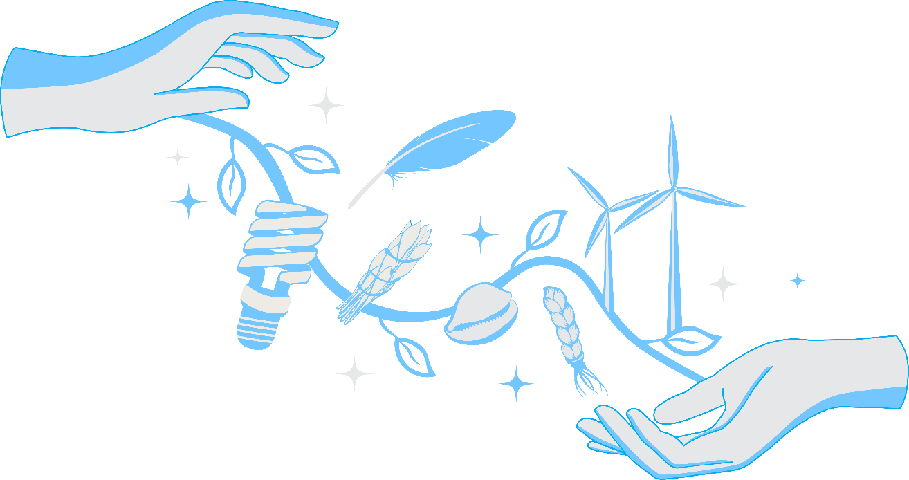
Passing the Bundle: It is time for change. Mother Earth is asking us to change our ways. Our children are asking us to change our ways. The journey has been long, and we have made it far and the younger generations will continue the journey long after we are gone. Putting our wisdom into our bundles to pass to the next generation is a wish, a prayer, it’s an act of hope and in this day and age, hope is an act of defiance, an act of revolution.
When we pass the bundle…we share what we have learned, we share the knowledge of those before us, we share the tools that have aided us, we give everything that has helped us to the next generation so they may carry on the spirit of living in a good way.
Passing the bundle means ensuring that it is ready to be received. Passing the bundle means knowing when to let go.
Proof of Concept:
Adam McLaren and Jennifer Schneider
Final Art Design:
Ray Fox - Ray Fox is a contemporary Indigenous artist whose work is rooted in ancestral knowledge, land connection, and cultural sovereignty. A proud 2-Spirit Anishinaabe creative, Ray blends traditional teachings and modern expression through drawing, painting, printmaking, and graphic art. His imagery reflects sacred responsibility of protecting Indigenous ways of knowing, while also celebrating identity, strength, and community resilience. Based in Sault Ste. Marie, Ray works from his art studio and facilitates community workshops that bring participants into a deeper relationship with Indigenous culture through hands-on creation. He is also the eLearn Designer at the Ontario Native Welfare Administrator’s Association.

